**1.5 Inverse of a Matrix**

**Definition:** If A is a square matrix, and if a matrix B of the same size can be found such that

$$AB=BA=I (Identity Matrix)$$

then A is said to be **invertible** (or **nonsingular**) and B is called an **inverse** of A. If no such matrix B can be found, then A is said to be **singular**.

The relationship $AB=BA=I$ is not changed by interchanging A and B, so if A is invertible and B is an inverse of A, then it is also true that B is invertible, and A is an inverse of B. Thus, when $AB=BA=I$,we say that A and B are inverses of one another.

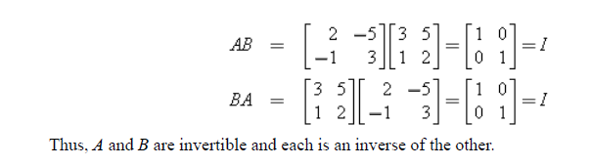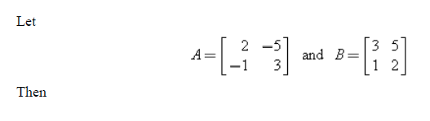

**Remarks:**

1. *In general, a square matrix with a row or column of zeros is singular.*
2. *An invertible matrix has exactly one inverse.*

**Formula for the Inverse of a matrix:**

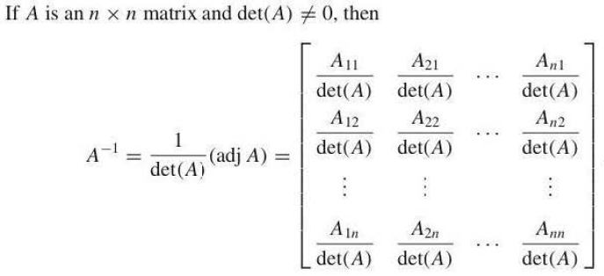

For a 2x2 matrix this formula is easy to use. For example 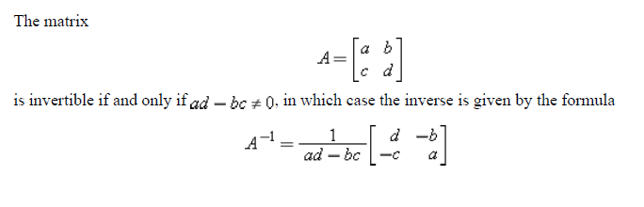

Example 1:

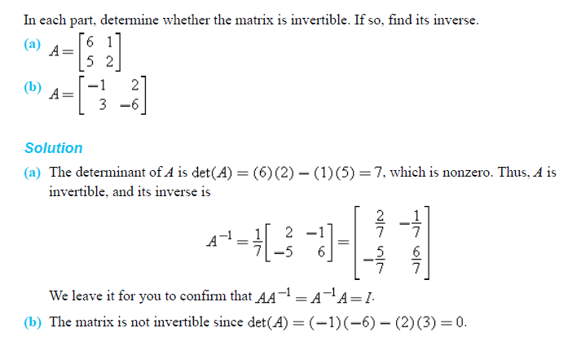

Example 2:

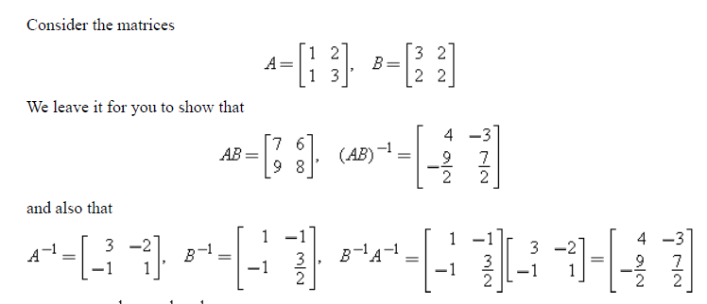

**Remark:**

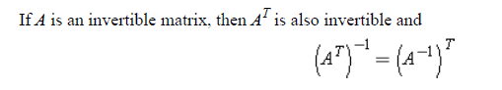

For a matrix of order higher than 2x2 we use the inversion algorithm to find its inverse (based on steps used for the reduced row echelon form).

**1.5 Inversion Algorithm**

To find the inverse of an invertible matrix *A*, find a sequence of elementary row operations that reduces *A* to the identity and then perform that same sequence of operations on $I_{n}$ to obtain $A^{-1}$.

Example 4:

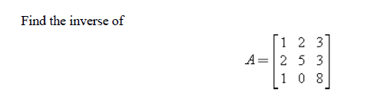

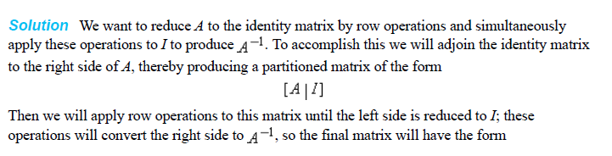

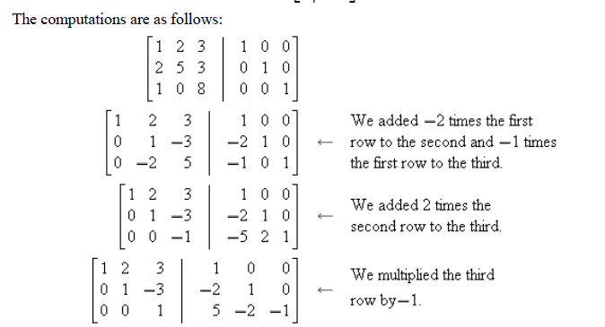

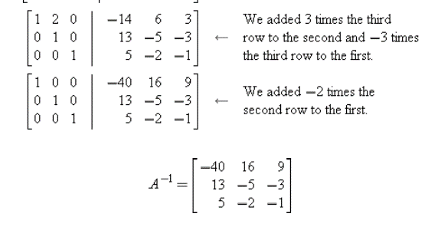

Example 5:

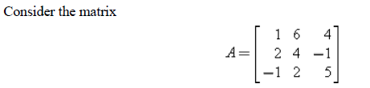

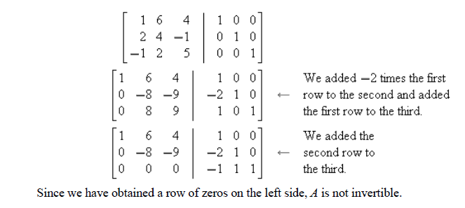

**Work to do**

**Q1.** Determine whether the statement is true or false, and justify your answer.

1. For all square matrices *A* and *B* of the same size

${(A+B)}^{2}=A^{2}+2AB+B^{2}.$

(ii) The product of two elementary matrices of the same size must be an elementary matrix.

(iii) If *A* is an $n×n$ matrix that is not invertible, then the linear system $Ax=0$ has infinitely many solutions.

(iv) It is impossible for a linear system of linear equations to have exactly two solutions.

(v) If *A* and *B* are invertible matrices of the same size, then *AB* is invertible and ${(AB)}^{-1}=A^{-1}B^{-1}.$

(vi) Every elementary matrix is invertible.

(vii) If *A* is invertible and a multiple of the first row of *A* is added to the second row, then the resulting matrix is invertible.

(viii) If the linear system $Ax=b$ has a unique solution, then the linear system $Ax=c$ also must have a unique solution.

**Q2.** Use the inversion algorithm to find the inverses of the given matrices, if exist.



$\left[\begin{aligned}1 2 -3 \\ 1 -2 1 \\ 5 -2 -3\end{aligned}\right] \left(ii\right) \left[\begin{aligned}0 2 3 \\ 1 1 1 \\ 5 5 1\end{aligned}\right]$

**(iii) $\left[\begin{aligned}2 6 6 \\ 2 7 6 \\ 2 7 7\end{aligned}\right] , \left(iv\right) \left[\begin{aligned}-1 3 -4 \\ 2 4 1 \\ -4 2 -9\end{aligned}\right]$, $(v) \left[\begin{aligned} 2 5 5 \\ -1 -1 0 \\ 2 4 3\end{aligned}\right]$**

**Q3.** Find all values of *c*, if any, for which the given matrix is invertible.

$\left[\begin{aligned}c c 1 \\ 1 1 c \\ 0 1 c\end{aligned}\right]$

$\left[\begin{aligned}c c -1 \\ 1 1 2c \\ 0 1 c\end{aligned}\right]$

$\left[\begin{aligned}c c c \\ 1 c c \\ 1 1 c\end{aligned}\right]$

Q4. Find det A and det B using row or column of your choice and using reduced matrix.

$$A=\left[\begin{aligned}-3 0 7 \\ 2 5 1 \\ -1 0 5\end{aligned}\right], B=\left[\begin{aligned}3 3 0 5 \\ 2 2 0 -2 \\ 4 1 -3 0 \\ 2 10 3 2\end{aligned}\right]$$

**Q5.** If $\left|\begin{aligned}a b c \\ d e f \\ g h i\end{aligned}\right|=-6$, then $\left|\begin{aligned}3a 3b 3c \\ -d -e -f \\ 4g 4h 4i\end{aligned}\right|=?$